Exercise 1: Implementing the Singleton Pattern

public class SingletonPattern{ static class Logger{
private static Logger instance; private Logger(){
System.out.println("Initializing the Logger");
}
public static Logger getInstance(){ if(instance==null){
instance=new Logger();
}
return instance;
}
public void logMessage(String msg){ System.out.println("Log: "+msg);
}
}
public static void main(String[] args){ Logger log1 = Logger.getInstance(); log1.logMessage("First log message"); Logger log2 = Logger.getInstance(); log2.logMessage("Second log message"); if(log1==log2){
System.out.println("Both loggers are the same instance");
}else{
System.out.println("Different instances");
}
} }

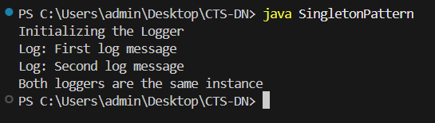

Exercise 2: Implementing the Factory Method Pattern

public class FactoryPattern{ interface Document{
void open();
}
static class WordDocument implements Document{ public void open(){
System.out.println("Opening a Word Document");
}
}
static class PdfDocument implements Document{ public void open(){
System.out.println("Opening a PDF Document");
}
}
static class ExcelDocument implements Document{ public void open(){
System.out.println("Opening an Excel Document");
}
}
abstract static class DocumentFactory{

public abstract Document createDocument();
}
static class WordDocFactory extends DocumentFactory{ public Document createDocument(){
return new WordDocument();
}
}
static class PdfDocFactory extends DocumentFactory{ public Document createDocument(){
return new PdfDocument();
}
}
static class ExcelDocFactory extends DocumentFactory{ public Document createDocument(){
return new ExcelDocument();
}
}

public static void main(String[] args){ DocumentFactory wordFac = new WordDocFactory(); Document wordDoc = wordFac.createDocument(); wordDoc.open();
DocumentFactory pdfFac = new PdfDocFactory(); Document pdfDoc = pdfFac.createDocument(); pdfDoc.open();
DocumentFactory excelFac = new ExcelDocFactory(); Document excelDoc = excelFac.createDocument(); excelDoc.open();
} }

